# About me

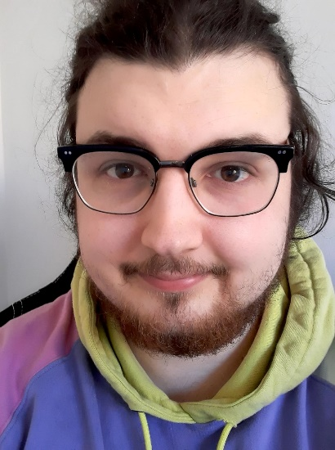

My name is Nikolaj Geisle and I am a nerd! I'm 25 years old, and right now I'm studying Computer Science at UCL Erhvervsakademi og Professionshøjskole in Odense. I live in Odense C with my best friend, and my girlfriend of two years is also almost my neighbour, so I have the two people closest to me at arm’s length. I got interested in programming in High School when I had a programming course, and now I'm pursuing an Education in Computer Science.

## **The 2 big passions**

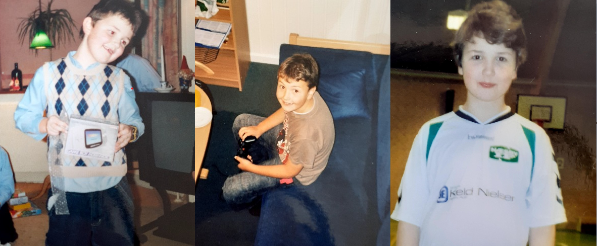

My love for computers & videogames started from when I was a fourth grader, and finally was able to get into the "club" at my school, this club has a PlayStation, which all the kids in the school were fighting to get some time to play, and as we were the youngest, we only got to watch the older kids play. I begged my parents for one, and after a couple of months, they finally gave in to my begging and bought me one. My father taught me how to play, and we played a lot together. It even was used by the whole family to often hold friendly (and by friendly, I of course mean very very serious and competitive) family tournaments. This love for videogames became even stronger when my parents bought me my own pc when I was 13, and ever since then, my love for videogames was cemented.

This love of videogames was also opposite another passion of mine, which was handball. If I wasn't at home playing videogames with my father, I was spending time in the local sports hall playing handball. I eventually got good enough to be scouted for "Odense Håndbolds" talent team when I was 14. That was when my time playing handball got ratcheted up, I usually trained for around 3 hours every other day. I loved the social life of playing handball, with all my friends around, we would have a lot of fun, but I also learned how important morale and teamwork is. I didn't enjoy the training as much as I thought I would, as it was rather rigorous. While half of my days were spent playing handball, the other half was of course spent playing videogames, and in the end when I was 18, I quit playing handball and my love of videogames became the passion that lasted, and I ended up building my own computer when I was 18.

So in the end videogames triumphed and as it triumphed I was also taking a intro course to Java programming in High-school, and that's where my love for programming started. This was only a seed though, as I became rather interested in programming, but at the time it was just a hobby. This seed would later sprout, as I was working full time in the flower industry (Pun intended). While doing this job I learned some essential skills like leadership skills & intercultural communication and I used those skills every day. But I was torn about what my future would look like, and I decided to get an education, that's when I remembered how much fun I had with programming in High School, and from then, I decided to study Computer Science.